Networking Ticket
- Request new static IP (10.30.180.35 ascending – can check during Tufin request)
- Request MAC be updated for static setup IP in Austin. Provide MAC of new install

Firewall (Tufin) Request
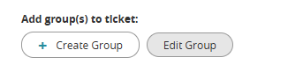
- New Request
- Select Edit Group
- Name: student_affairs_brightsigns
- Click Add. Ok.
- Add and remove devices manually
- Select Submit in bottom right corner

brightAuthor connected
- Navigate to Admin → Provision
- Select +Add Player. Enter Player info (serial number is appended to name)

